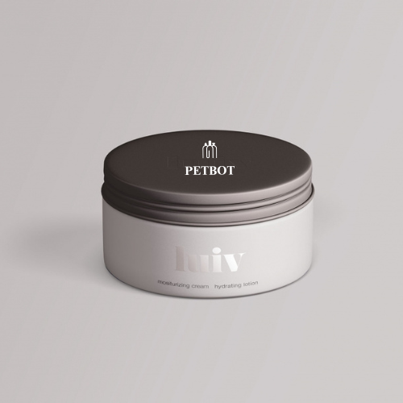

**Plastic Jars Skin Care**

MOQ:

For **stock** Plastic jars, the MOQ is 10,000 pieces.  
For **custom** requirements, please refer to the following MOQ：

* Jars under 100ml - 100,000 pcs
* Jars in 100~150ml - 30,000 pcs
* Jars larger than 150ml - 50,000 pcs

**CUSTOMIZATION:**

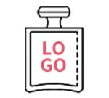

Logo

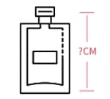

Size

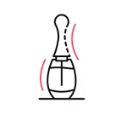

Shape

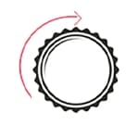

Cap